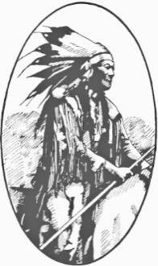
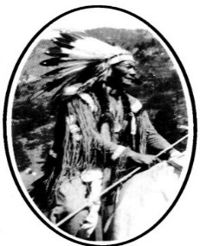
Ute Pass Historical Society
P.O. Box 6875 Woodland Park, Colorado 80866
(719)686-7512 ∙ uphs@peakinter.net
UtePassHistoricalSociety.org

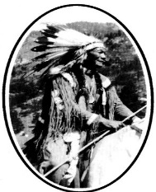

2024 Patronage Invitation
By becoming a patron of UPHS, you provide needed funds that help the Society preserve and protect our region’s historical heritage. Your support helps maintain History Park, the Museum Center, educational programs and our collection of artifacts, documents, photographs and oral histories. Thank you for joining with us in keeping our exciting history alive!
Patronage is effective through December 31.

Name(s):
Company:
Mailing Address:
City, State, Zip:
Home Phone: Cell Phone:
Email: Date:
New Patron Renewing Patron
I want to receive the Chamber Grapevine every week.
I want to receive my newsletter by email only.
I want to volunteer! Please contact me with information about volunteer opportunities.

Dues and Benefits
10% discount at the UPHS Gift Shop ∙ UPHS quarterly newsletter ∙ Free or discounted admission
to UPHS-sponsored events

 |  |  | Patronage Level | Additional Benefits
 | $ | 30 | Individual
 | $ | 40 | Family / Associate
 | $ | 50 | Business / Supporting | A 5” x 7” reprint of your choice from our photo archives
 | $ | 100 | Benefactor | An 8” x 10” reprint of your choice from our photo archives
 | $ | 250 | President’s Club | Your choice of any book in the UPHS Gift Shop or an 8” x 10” reprint
 | $ | 500 | Historical Club | Your choice of any book in the UPHS Gift Shop and an 8” x 10” reprint

I want to help UPHS preserve and share our region’s history. I am also enclosing a tax-deductible donation of $_______________. I would like UPHS to use these funds for:
Whatever is needed most General Fund to support administrative costs Collections and exhibits

Total amount (membership and optional donation) of my enclosed check is $_____________.
Mail your check and this completed form to: UPHS P.O. Box 6875 Woodland Park, CO 80866
UPHS is a 501(c)(3) non-profit organization, ID #84-0731460.
For UPHS use:
Ck #: ________ Amt: ________ Date processed: __________ Processed by: __________ Level: __________

